**Lab 3: Linux Basic Scripting**

1. **Write a shell script to print your name.**

**Shell Script:**

echo "What is your name?"

read Person

echo "Hello $Person"

**Command Output:**

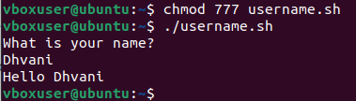

1. **Write a shell script to find whether a number is even or odd.**

**Shell Script:**

echo "--- EVEN OR ODD IN SHELL SCRIPT ---"

echo -n "Enter a Number: "

read N

echo -n "RESULT: "

if [ $((N%2)) -eq 0 ]

then

echo "$N is even"

else

echo "$N is odd"

fi

**Command Output:**

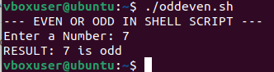

1. **Write a script to print a table of a given number.**

**Shell Script:**

echo "Enter a Number: "

read N

echo -n "Multiplication table of $N is: "

i=1

while [ $i -le 10 ]

do

echo " $N * $i = `expr $N \* $i ` "

i=`expr $i + 1`

done

**Command Output:**

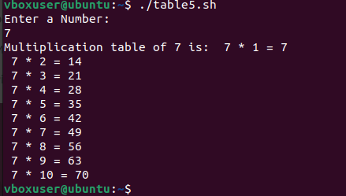

1. **Write a shell script to check whether a given no. is prime or not.**

**Shell Script:**

echo "Whether the given number is prime or not"

echo -n "Enter the number: "

read N

i=2

flag=0

while test $i -le `expr $N / 2`

do

if test `expr $N % $i` -eq 0

then

flag=1

fi

i=`expr $i + 1`

done

if test $flag -eq 1

then

echo "$N is not a Prime Number"

else

echo "$N is a Prime Number"

fi

**Command Output:**

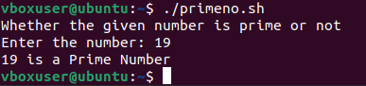

1. **Write a shell script to find the simple interest.**

**Shell Script:**

echo "Finding The Simple Interest"

echo -n "Enter the principle value: "

read p

echo -n "Enter the time period: "

read t

echo -n "Enter the rate of interest: "

read r

i=` expr $p \* $t \* $r `

i=` expr $i / 100 `

echo "The Simple Interest is: $i"

**Command Output:**

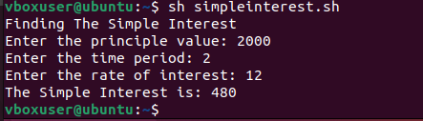

1. **Write a shell script to find sum of “n” numbers.**

**Shell Script:**

echo "Sum of N numbers"

echo -n "Enter Size(N): "

read N

i=1

sum=0

echo "Enter Numbers"

while [ $i -le $N ]

do

read num

sum=$((sum + num))

i=$((i + 1))

done

echo "The Sum of the N numbers is: $sum"

**Command Output:**

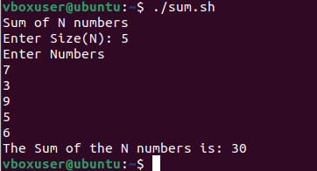

1. **Write a shell script to find the largest number of three numbers.**

**Shell Script:**

echo "Finding Greater Number Among 3 Numbers"

echo -n "Enter Num1: "

read num1

echo -n "Enter Num2: "

read num2

echo -n "Enter Num3: "

read num3

if [ $num1 -gt $num2 ] && [ $num1 -gt $num3 ]

then

echo "The Greater number among 3 number is $num1"

elif [ $num2 -gt $num1 ] && [ $num2 -gt $num3 ]

then

echo "The Greater number among 3 number is $num2"

else

echo "The Greater number among 3 number is $num3"

fi

**Command Output:**

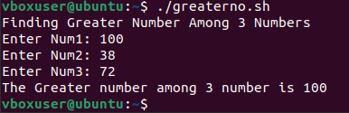

1. **Write a shell script for menudriven calculator.**

**Shell Script:**

#!/bin/bash

sum=0

i="y"

echo "CALCULATOR PROGRAM"

read -p "Enter first number :" n1

read -p "Enter second number :" n2

while [ $i = "y" ]

do

echo "Menu"

echo "1.Addition"

echo "2.Subtraction"

echo "3.Multiplication"

echo "4.Division"

echo "Enter your choice"

read ch

case $ch in

1)sum=`expr $n1 + $n2`

echo "Sum ="$sum;;

2)sub=`expr $n1 - $n2`

echo "Sub = "$sub;;

3)mul=`expr $n1 \* $n2`

echo "Mul = "$mul;;

4)div=`echo $n1 / $n2 | bc -l`

echo "Div = "$div;;

*)echo "Invalid choice";;

esac

echo "Do u want to continue ? [y/n]"

read i

if [ $i != "y" ]

then

exit

fi

done

**Command Output:**

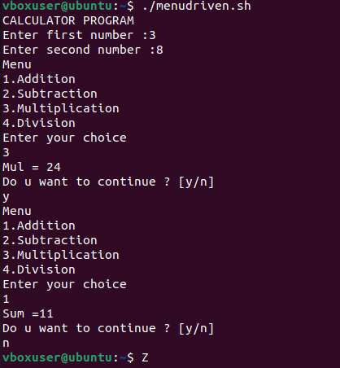

1. **Write a Shell script to find Fibonacci series.**

**Shell Script:**

echo "How many number of terms to be generated in Fibonacci series ?"

read n

function fib

{

x=0

y=1

i=2

echo "Fibonacci Series up to $n terms :"

echo "$x"

echo "$y"

while [ $i -lt $n ]

do

i=`expr $i + 1 `

z=`expr $x + $y `

echo "$z"

x=$y

y=$z

done

}

r=`fib $n`

echo "$r"

**Command Output:**

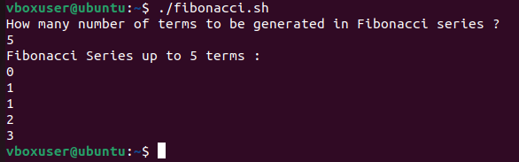

1. **Write a Shell script to find leap year.**

**Shell Script:**

­read -p "Enter the Year:" y

year=$y

y=$(( $y % 4 ))

if [ $y -eq 0 ]

then

echo "$year is Leap Year!"

else

echo "$year is not a Leap Year!"

fi

**Command output:**

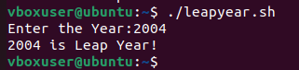

1. **Write a Shell Script to find half pyramid of numbers.**

**Shell Script:**

num=1

rows=5

for((i=1; i<=rows; i++))

do

for((j=1; j<=i; j++))

do

echo -n "$num "

num=$((num + 1))

done

num=1

echo

done

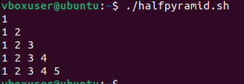

1. **Write a Shell Script to uppercase any string.**

**Shell Script:**

read -p "Enter the string:" s

upperstr=$(echo $s | tr '[:lower:]' '[:upper:]')

echo "Inputed Lowercase String : $s"

echo "Uppercase String : $upperstr"

**Command output:**

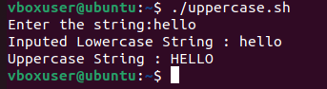

1. **Write a Shell script to find reverse of given number.**

**Shell Script:**

read -p "Enter a number: " number

temp=$number

while [ $temp -ne 0 ]

do

reverse=$reverse$((temp%10))

temp=$((temp/10))

done

echo "Reverse of number is $reverse"

**Command output:  
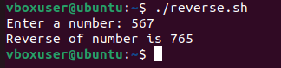**

1. **Write a Shell Script to sum of all digits.**

**Shell Script:**

read -p "Enter a number:" num

sum=0

while [ $num -gt 0 ]

do

mod=`expr $num % 10`

sum=`expr $sum + $mod`

num=`expr $num / 10`

done

echo "Sum of all digits in the number is "$sum

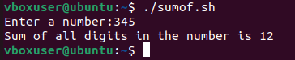

1. **Write a Shell Script to find factorial of given number.**

**Shell Script:**

read -p "Enter a number:" num

fact=1

for((i=2;i<=num;i++))

{

fact=$((fact * i)) #fact = fact * i

}

echo "The factorial of $num is $fact"

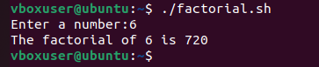

1. Write a Shell Script to find valid argument.

Shell Script:

cho $1 $2 $3 $4

if [ $#

-eq 4 ]

then

echo "Valid arguments"

else

echo "Invalid arguments"

fi

